# Machine Learning

#### What is Machine Learning?

Machine Learning is a subset of Artificial intellegence It focuses mainly on the designing of systems, thereby allowing them to learn and make predictions based on some experience which is the data in case of machines.

Machine learning enables computer to act and make data-driven decisions rather than being explicitly programmed to carry out the certain task, these programs are designed to learn and improve over time when exposed to new data.

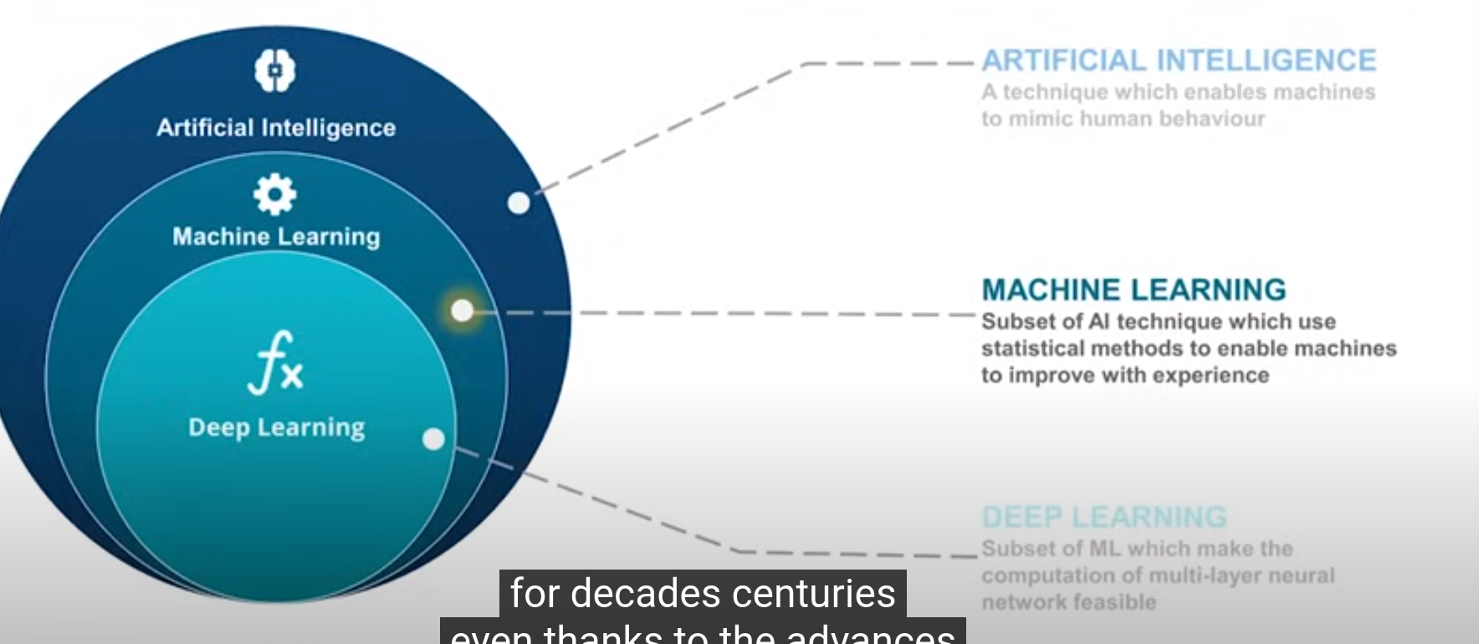

#### Types of Machine Learnings:

1. Supervised
2. Unsupervised
3. Reinforcement